CDP and LLDP
CCNA study notes · Layer 2 discovery protocols

1. Layer 2 discovery protocols
- Layer 2 discovery protocols such as CDP and LLDP share information with, and discover information about, neighbouring (directly connected) devices.
- They are called Layer 2 discovery protocols because the protocols themselves operate at Layer 2.
- The information shared includes host names, IP addresses, device type, and so on.
- CDP is a Cisco proprietary protocol, developed by Cisco.
- LLDP is an industry standard protocol (IEEE 802.1AB).
- If your network uses only Cisco devices, CDP is fine. If there is a mix of vendors (for example a Cisco router with Juniper switches), you must use LLDP.

Security consideration
Because these protocols share information about network devices, they can be a security risk: unauthorized users could learn about the network.
They are therefore often not used. It is up to the network engineer or administrator to enable or disable them based on the network's security requirements.

2. How the protocols work
To demonstrate, take two intermediary devices that are directly connected: R1 (a router) and SW1 (a switch).
- R1 periodically sends frames to SW1 containing information such as its host name, IP address and device type.
- SW1 does the same, periodically sending frames to R1.
- SW1 does not include an IP address in what it sends, because its interfaces do not have an IP address (it is a Layer 2 switch).
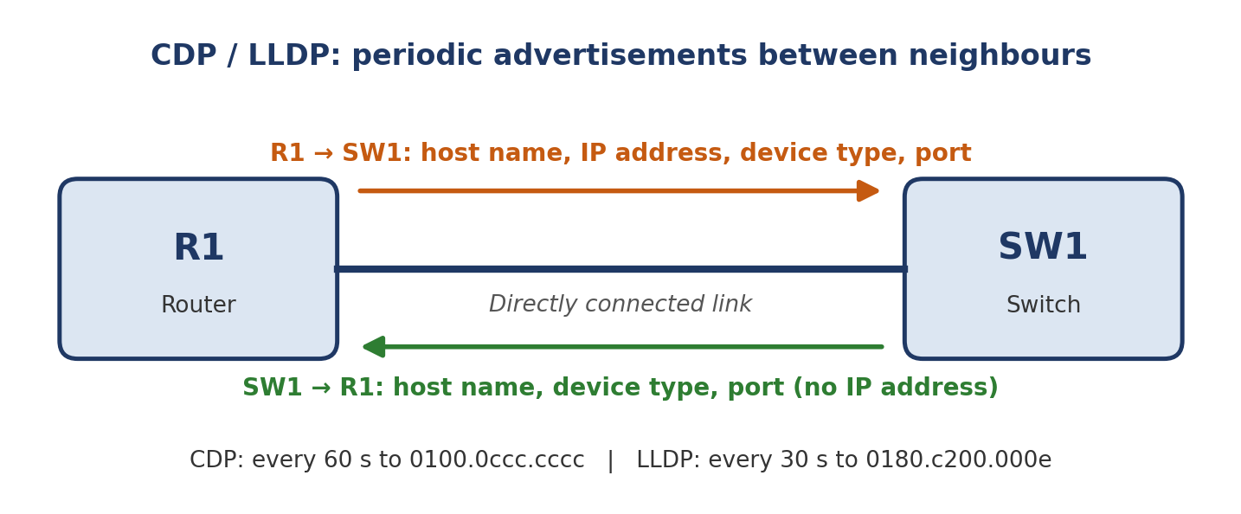
Figure 1: R1 and SW1 advertising information to each other

3. CDP (Cisco Discovery Protocol)

Basics
- A Cisco proprietary protocol, enabled by default on Cisco devices.
- Two versions exist, CDPv1 and CDPv2. CDPv2 is sent by default.
- Only directly connected neighbours can become CDP neighbours.

Messages
- CDP messages are sent periodically to the multicast MAC address 0100.0ccc.cccc.
- Because the address is multicast, you might think the message is forwarded to multiple devices. It is not: a device that receives a CDP message processes it and discards it, and does not forward it to other devices.
- The special multicast address lets a Cisco device say, in simple terms, “any Cisco device connected to this link, listen to this message.”
- Multicast is how the message is addressed. CDP discovery is what the message is used for: finding directly connected Cisco neighbours and learning their device name, port, IP address and device type.

Timers
- CDP messages are sent every 60 seconds.
- When a device receives a CDP message, it adds an entry for that neighbour in its CDP neighbours table.
- The default hold time is 180 seconds. If no message is received from a neighbour for 180 seconds, the neighbour is removed from the CDP neighbours table.

Key rule
CDP: every 60 s, hold time 180 s, sent to 0100.0ccc.cccc. Received messages are processed and not forwarded.

4. LLDP (Link Layer Discovery Protocol)
- An industry standard protocol (IEEE 802.1AB).
- CDP was the original. LLDP was invented later to provide an industry standard version.
- It is usually disabled by default on Cisco devices, so it must be enabled manually.
- A device can run CDP and LLDP at the same time, so you do not have to choose.
- LLDP messages are sent periodically to the multicast MAC address 0180.c200.000e.
- A device that receives an LLDP message processes and discards it. It does not forward it to other devices.
- By default, LLDP messages are sent once every 30 seconds.

Key rule
LLDP: every 30 s, sent to 0180.c200.000e, off by default on Cisco devices, so enable it manually.

5. CDP vs LLDP
Feature | CDP | LLDP
Type | Cisco proprietary | Industry standard (IEEE 802.1AB)
Best used when | Network is all Cisco | Mixed vendors (Cisco, Juniper, etc.)
Default on Cisco devices | Enabled | Usually disabled (enable manually)
Multicast MAC address | 0100.0ccc.cccc | 0180.c200.000e
Send interval | Every 60 seconds | Every 30 seconds
Hold time (default) | 180 seconds | Not covered in these notes
Forwards received messages? | No (processed and discarded) | No (processed and discarded)
Neighbours | Directly connected only | Directly connected only

CCNA tip
CDP and LLDP can run together on the same device. Disable them where the information they reveal is a security risk, for example on ports facing untrusted networks.

